1. Supplier : select PTypeStores,*from masterlen
Load from Mapped Party type eg:‘C1,C4,C5,C6,C7,C8,C9,CC,CE,CM,CN,CO,CV’
Select slcode,slname from fa_slmas where left(slcode,2) in (select items from dbo.split(@Ptype,’,’))

2.TCS column not required in the middle .already available near IGST Amount
3.Landed Cost -After TCS Amount column
- 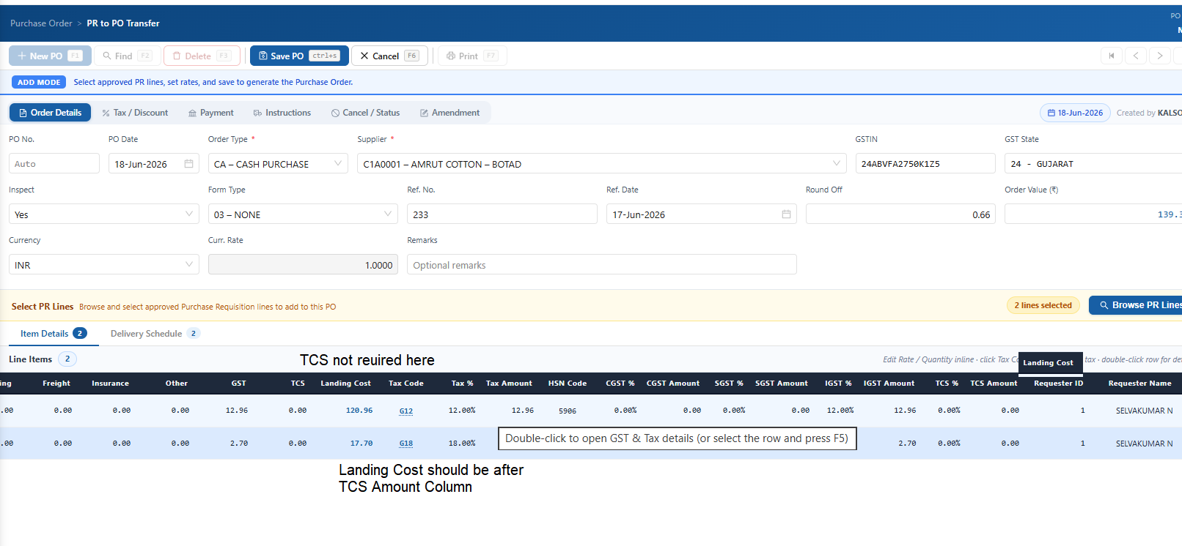

4. ItemGrid -in browser 100% view not viewable.
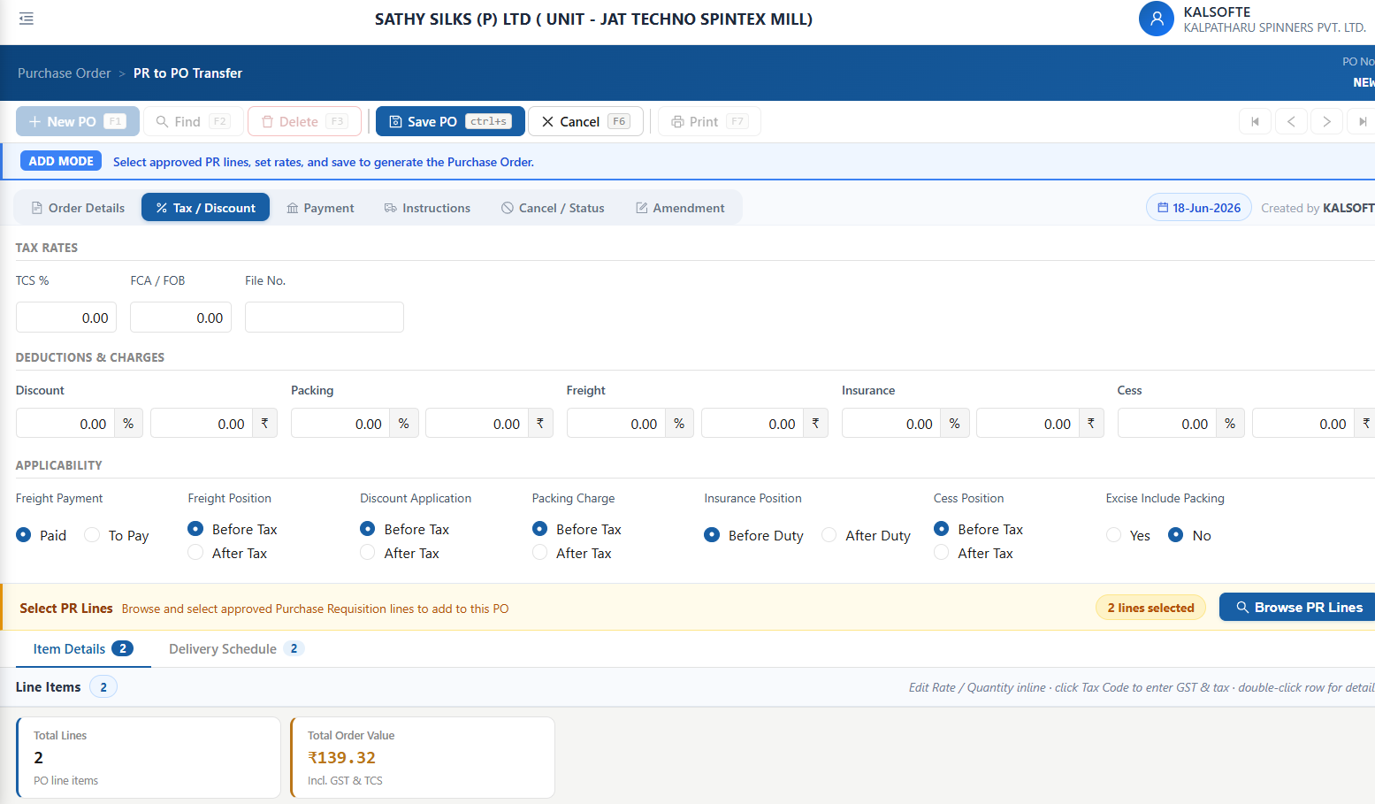

- Header Amount not refelected in Itemgrid relevant column. Some time -check later
- Round off should accept negative Value(Eg: -.36)

